PROJECT REPORT

***Vehicle Reservation System***

Submitted to

GALGOTIAS UNIVERSITY

BY

Amulya Arun

Ayushi Verma

Meenal Gupta

Sapna Sangmitra

Varun Vaish

UNDER THE GUIDANCE OF PROF. **Mr. Abhinandan Chivate**

AT COGNIZANT TECHNOLOGICAL SOLUTIONS

2019

|  |  |  |  |  |  |  |  |  |
| --- | --- | --- | --- | --- | --- | --- | --- | --- |
| |  | | --- | | School of Computer Science And Engineering | | **GALGOTIAS UNIVERSITY**  (Deemed University)  Greater Noida  February 2019-April 2019 | |  | |  | |  | |  | | | |
|  | | |
|  | | |
|  | | |
|  | | |
|  | | |
|  | | | |
|  | | | |
| **CERTIFICATE**  This is to certify that the project report entitled **Vehicle Reservation System.**  Amulya Arun  Ayushi Verma  Meenal Gupta  Sapna Sangmitra  Varun Vaish   |  |  | | --- | --- | |  |  |   in partial fulfilment of the requirements for the award of the **Degree of Bachelor of Technology** in **Computer Science And Engineering** is a bonafide record of the work carried out under my(our) guidance and supervision at Cognizant Technological Solutions, Pune. | | | |
| Signature of Supervisor 1  Mr. Abhinandan  Trainer and Mentor  Cognizant Technological Solutions | Signature of Supervisor 2  Mrs. Shilpa Mahajini  HR  Cognizant Technological Solutions |

|  |  |
| --- | --- |
| **The Project was evaluated by us on _____________** | |
|  | |
| EXAMINER 1 | EXAMINER 2 |
| EXAMINER 3 | EXAMINER 4 |

ACKNOWLEDGEMENTS

We feel immense pleasure and feel privileged in expressing our deepest and most sincere gratitude to our supervisor **<>** for her excellent guidance throughout our project work. His kindness, dedication, hard work and attention to detail have been a great inspiration to us. Our heartfelt thanks to you ma’am for the unlimited support and patience shown to us. We would particularly like to thank her for all her help in patiently and carefully correcting all our manuscripts. We acknowledge the support received from Cognizant company, Pune.We are also very thankful to **<>** B.tech project coordinator (CSE department), Associate Dean Professor **<>** and **<>**, Dean (School Of Computer Science And Engineering) for their support and suggestions during our course of the project work in the final year of our undergraduate course.

Amulya Arun

Ayushi Verma

Meenal Gupta

Sapna Sangmitra

Varun Vaish

ABSTRACT

**Cognizant** is an American multinational corporation that provides IT services, including digital, technology, consulting, and operations services. It is headquartered in Teaneck, New Jersey,United States of America. Cognizant is included in the NASDAQ-100 and the S&P 500 indices. It is also one of the fastest growing Fortune 500 companies. It was founded as an in-house technology unit of DUN & BRADSTREEIN in 1994, and started serving external clients in 1996.

Cognizant had a period of fast growth during the 2000s, becoming a Fortune 500 company in 2011. In 2015, the FORTUNE Magazine named it as the world's fourth most admired IT Services company. In 2017, Cognizant was named in Fortune’s Future 50 list.

Cognizant provides information technology, information security, consulting, ITO and BPO services. These include business & technology consulting, system integration, application development & maintenance, IT infrastructure services, analytics, business intelligence data , warehousing, customer relationship management, supply chain management, engineering & manufacturing solutions, enterprise resource planning, research and development, outsourcing, and testing solutions.

Cognizant has three key practice areas that span its business — Digital Business, Digital Operations, and Digital Systems & Technology.

**Chapter 1**

Introduction

1. **Purpose of this Project**

This Project is aimed at:

• This Project is about the vehicle reservation and user login. And changes to be made into the inventory of the same.

• This project is about Vehicle Reservation System where the user logs in, register himself/herself with respective vehicles

•User can search for a particular vehicle in the database which involves the condition according to the service due date and insurance due date.

•Details of the vehicle can be edited and saved to the database through the update functionality.

This expiry of the insurance date would be further notified to the user end.

The purpose of this document is to systematically capture requirements for the project and the system to be developed. The document also captures the Functional requirements and serves as an input for the scope of project.

1.1 Objectives

Below are the objectives that shall be fulfilled post the execution of this project:

• User registration and credential authentication.

• Requests for service by user.

• Details based searching of vehicles.

• Accepting requests for new vehicle addition.

• Customer will also be notified for the expiry of the insurance date within a fortnight.

• Real time navigation.

1.2 Intended Audience

• Interns/Project Team

• Mentors and SME’s

**1.1.0 Business Case**

With the addition of a vehicle with a user, involving certain details attached to a certain vehicles, it is required and preferred to maintain a database regarding the same. The system will facilitate the addition of new vehicles in the system. Searching and updating the details of a certain vehicle would be another feature.

The solution developed will address the objective in a holistic manner and will have all the features and functionalities which shall let the portal allow a customer to perform a location based search, browse by the nature of service offered and contact info. This shall allow the process to accept the request from the userand a real time navigation can be performed. Email notification to the user for the service will be an added feature.

**1.1.2 Hardware and Software Requirements**

|  |  |  |
| --- | --- | --- |
| **Technology:** | **Hardware:** | **Software:** |
| Java | Desktop PC with 8GB RAM | 1. Node.js 10.15.1  2. Angular 5.0  3. Visual Studio Code 1.30  4. Eclipse IDE for Java EE Developers (Oxygen)  5. Maven 3.6.0  6. Tomcat 9  7. MySQL Community Server 8.0  8. MySQL Workbench  9. Putty  10. WinSCP  11. Oracle 11g express version |

**1.1.3 Product Scope**

This product is a powerful web aggregation engine is a core enabling technology of Cognizant solutions and is a fundamental tool for improving the management of collections and deductions. This product is a great start to an efficiency initiative.

**1.1.4 Definition**

• User: Client who is using our software.

• Customer(New User): Client side end-customers. The users actually starting to add new entries as system.

• Search: They are vehicles the system will retrieve from the database according to the details which is used to search the particular vehicle by..

• Update: This deals with the updation of vehicle details by User. The ‘user’ here shall be the operator of the system and will be responsible for the updation of vehicle details.

• Insertion: This use case deals with the addition of new vehicle entry. The ‘user’ here shall be the operator of the system and will be responsible for the insertion of the new vehicle.

• Notification: The customer will receive a notification email on the basis of the expiry date of the insurance due.

**Chapter 2**

2.0 Process Architecture

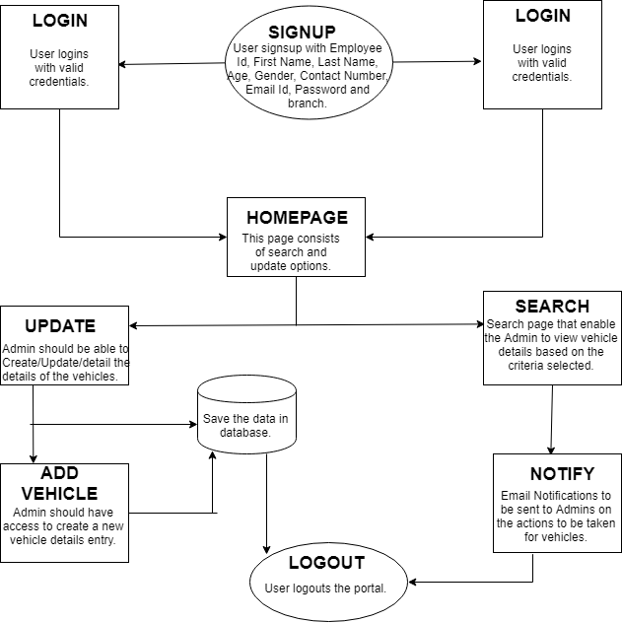

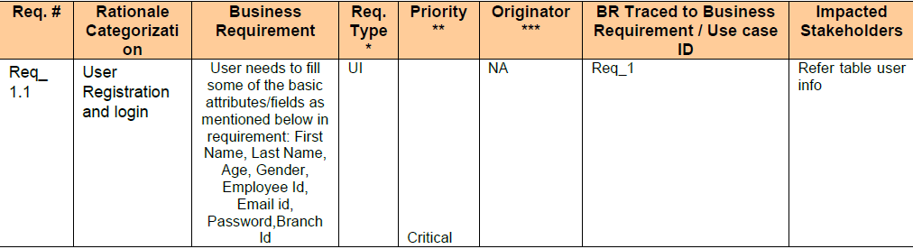

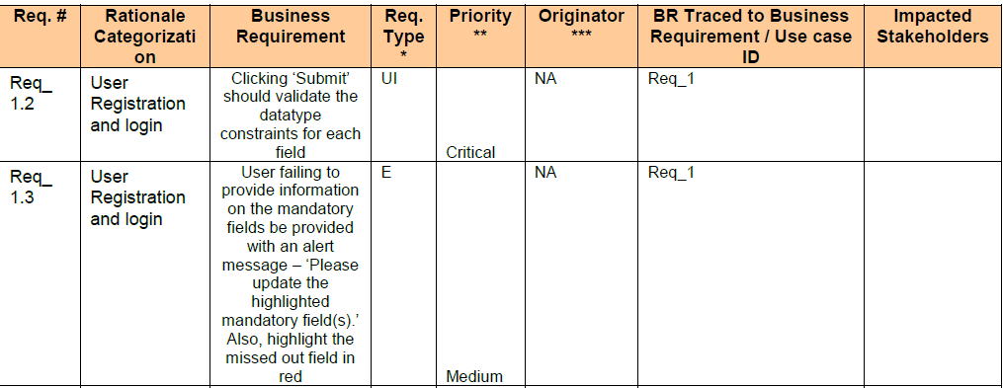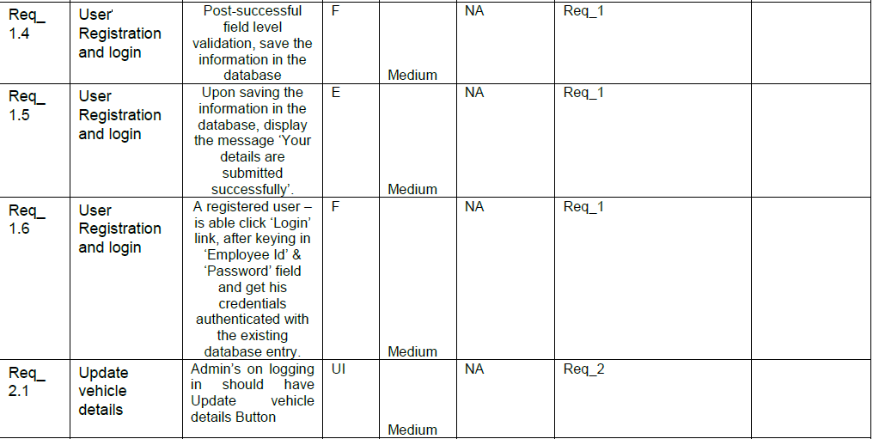

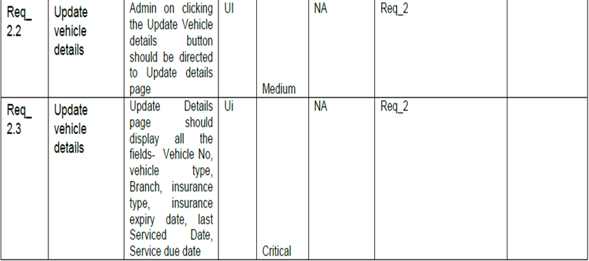

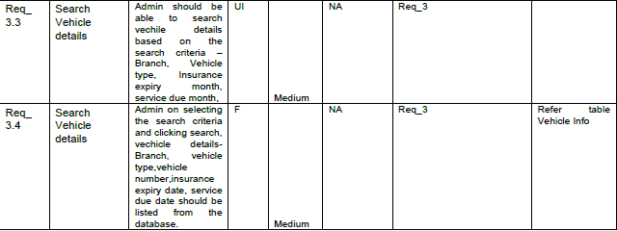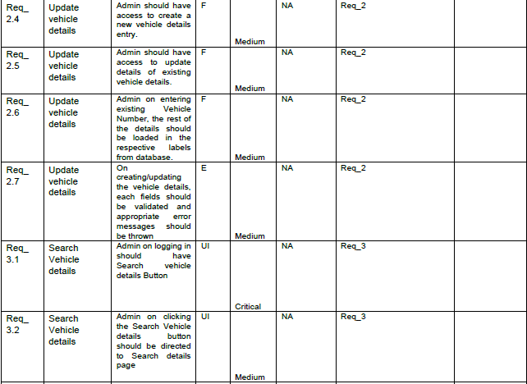

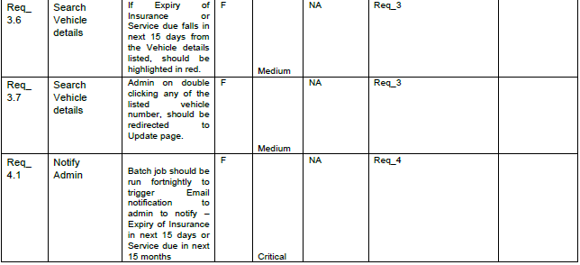

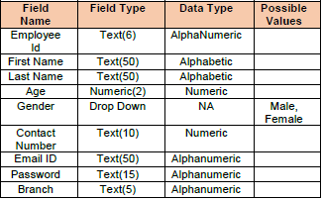



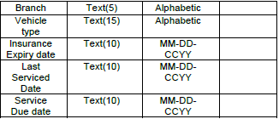

CODES REQUIRED FOR FRONTEND(HTML)

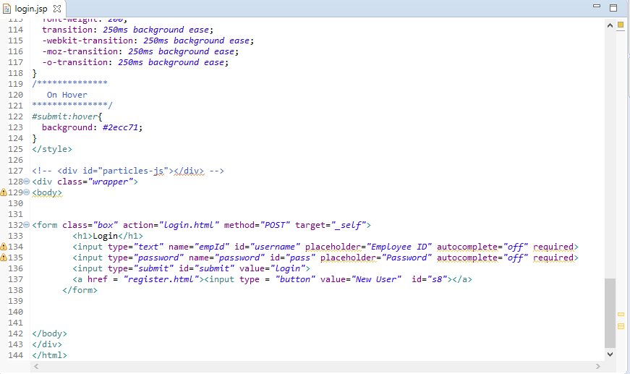

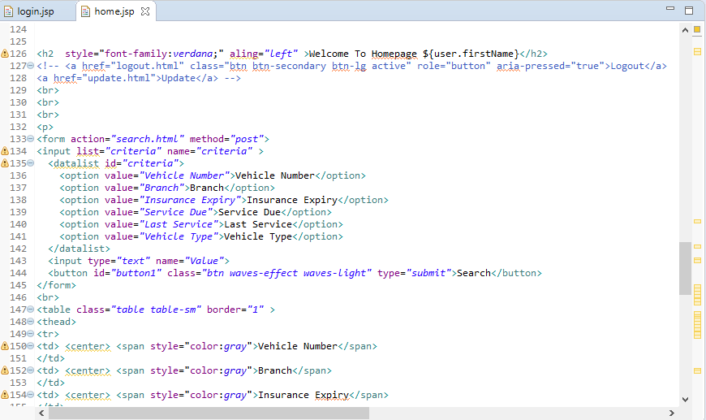

CODES REQUIRED FOR MIDDLEWARE

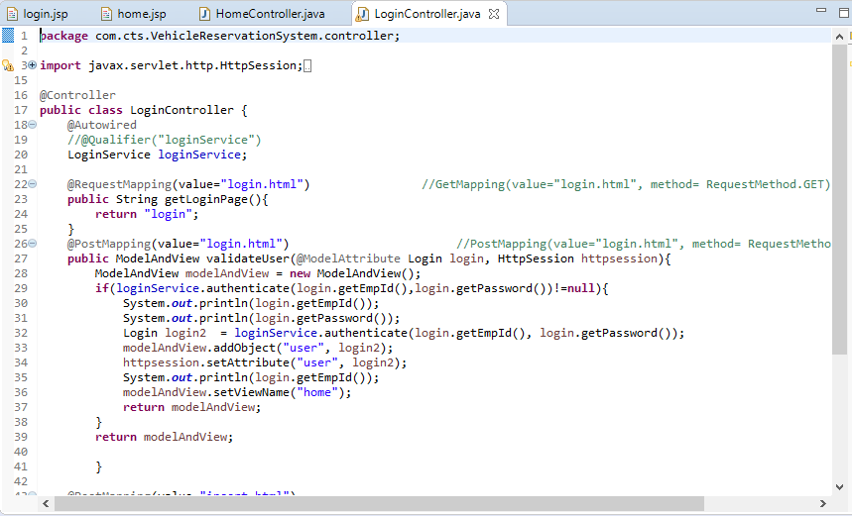

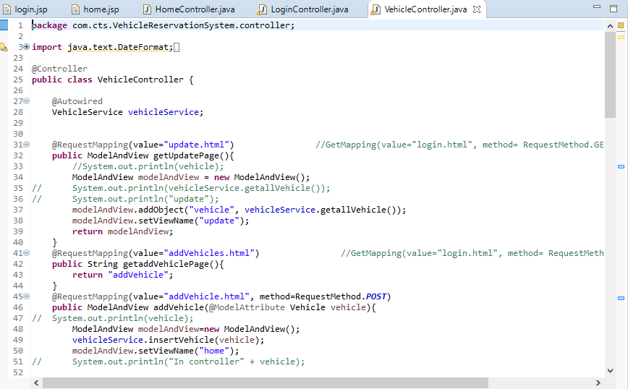

CODES FOR BACKEND

